

Figure 1: Eco Economic Epochs: Eco sustainable incentives for the programmable Economy



Fig 3: Eco sustainable incentives coded into a system of systems economic framework

USPTO 13/573,002: Time-Space Meter / Syntax Lexicon Rosetta Stone / Adaptive Procedural Template

DESCRIPTION: Systems of Federated Systems signaling, telemetry support framework for net, net of programmable money, econometrics for DAO Distributed Autonomous Organizations / trade federations participating in a new model eco sustainable programmable economy. Many use cases, one method fits many, not one size fits all.

SUMMARY: Checklists (adaptive procedural template in patent application speak) are visually boring and do not capture attention so this graphic is a picture of a checklist of useful tools, procedures, processes, algorithms, ideas that for example, a trade federation would agree to use to achieve, maintain their collective goals of the distributed federation. Adaptive Procedural Template forming / supporting a system of federated systems with a distributed signaling, telemetry (OPORD Annex K) framework derived from DARPA / Pentagon / NATO's Common Operational Picture COP-SIOP Single Integrated Operational Picture / system of systems engineering family of systems (swords to plowshares) / German Army suggestion circa 2003 to use COP - SIOP (Common Operational Picture, Single Integrated Operational Picture) Battlefield Digitization Digital Dashboard procedures for OOTW Operations Other Than War



Figure 4: Epoch Time Cycles / Syntax two main building blocks for web, web of $$$

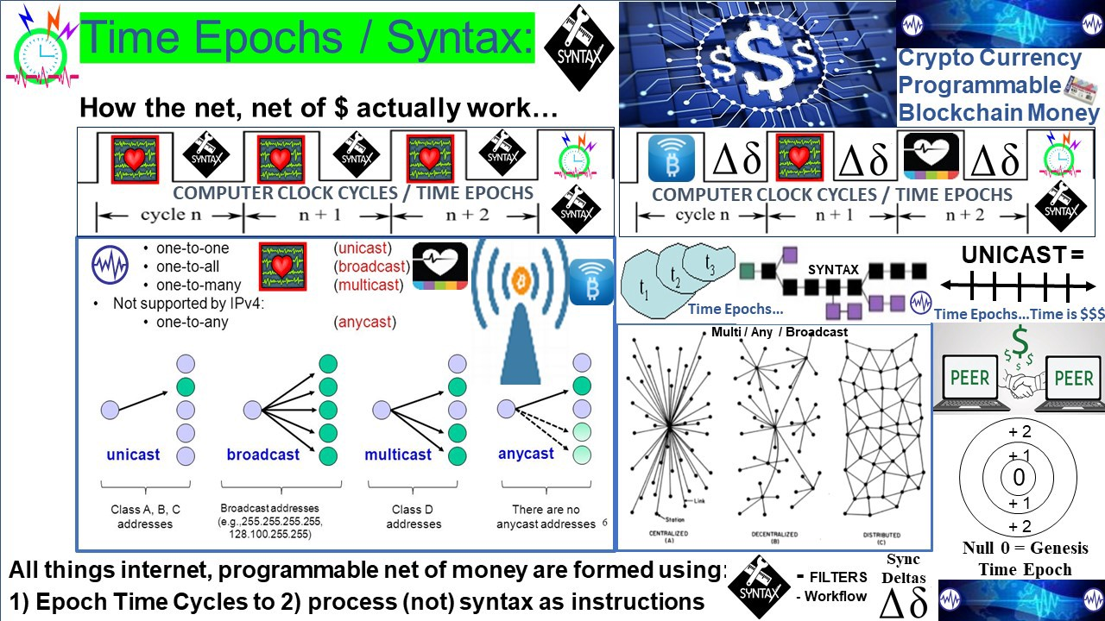

Figure 5: Time Epochs / Syntax: how the internet actually works: Unicast / Multicast IP

TITLE: Systems of Federated Systems signaling, telemetry support framework for all things net, net of programmable money, econometrics for DAO Distributed Autonomous Organizations / trade federations participating in a new model eco sustainable programmable economy

DESCRIPTION: Adaptive Procedural Template forming / supporting a system of federated systems with a distributed signaling, telemetry (OPORD Annex K) framework derived from DARPA / Pentagon / NATO's Common Operational Picture COP-SIOP Single Integrated Operational Picture / system of systems engineering family of systems dating from the mid 1990's (swords to plowshares) / German Army suggestion to use COP - SIOP Battlefield Digitization Digital Dashboard procedures for OOTW Operations Other Than War circa 2003 as a swords to plowshare inspired project / initiative

USPTO 13/573,002: The Heart Beacon Cycle Time - Space Meter Adaptive Procedural Template (checklist of useful tools, procedures, products...).

FUNDAMENTAL TRUTH: All things internet, net of money blockchains are formed by unicast, multicast, anycast protocols. Programmable money’s improvements are in cryptography.

Heart Beacon Cycle Time – Space Meter: One method fits many not one size fits all



Fig 2: Eco sustainable Economic Epochs coded into a systems of systems framework

USPTO 13/573,002: Time-Space Meter / Syntax Lexicon Rosetta Stone / Adaptive Procedural Template Checklists (adaptive procedural template in patent application speak) are visually boring and do not capture attention so this graphic is a picture of a checklist of useful tools, procedures, processes, algorithms, ideas that for example, a trade federation would agree to use to achieve, maintain their collective goals of the distributed federation. Many use cases, one method fits many, not one size fits all.

TITLE: Distributed signaling, telemetry framework dashboard: Earth Intelligence Network EIN / GDP GNI GNP + index economy

DESCRIPTION: Systems of Federated Systems signaling, telemetry support framework for net, net of programmable money, econometrics for DAO Distributed Autonomous Organizations / trade federations participating in a new model eco sustainable programmable economy. Eco sustainable Economic Epochs for the programmable Economy

USPTO 13/573,002: Time-Space Meter / Syntax Lexicon Rosetta Stone / Adaptive Procedural Template Checklists (adaptive procedural template in patent application speak) are visually boring and do not capture attention so this graphic is a picture of a checklist of useful tools, procedures, processes, algorithms, ideas that for example, a trade federation would agree to use to achieve, maintain their collective goals of the distributed federation. Many use cases, one method fits many, not one size fits all.

USPTO 13/573,002: The Heart Beacon Cycle Time - Space Meter Adaptive Procedural Template (checklist of useful tools, procedures, products, algorithms, econometrics, processes, metrics, meters, e.g., time - space, geo-spatial, temporal, cryptocurrency data storage into a "blockchain cube" with highth, width, depth, volume..) = universal programmable money metrics, meters for all metaphors, memes

SUMMARY: Adaptive Procedural Template forming / supporting a system of federated systems with a distributed signaling, telemetry (OPORD Annex K) framework derived from DARPA / Pentagon / NATO's Common Operational Picture COP-SIOP Single Integrated Operational Picture / system of systems engineering family of systems dating from the mid 1990's (swords to plowshares) / German Army suggestion to use COP - SIOP (Common Operational Picture, Single Integrated Operational Picture) Battlefield Digitization Digital Dashboard procedures for OOTW Operations Other Than War circa 2003

USE CASE: checklist of items that a distributed global Trade Federation (s) need to for a global digital economic framework digital dashboard: GDP Gross Domestic Product Economy EIN Earth Intelligence Network / Eco Economic Epoch Heartbeats for a programmable economy World Economic Forum WEF GDP - GNP enhancements

Use Cases: GDP Gross Domestic Product Index based Economy / National - Global currency / Eco #Economic Epochs Time-Space Meter #ecology Eco incentives, consensus, interoperability, sync, stochastic UTZ harmonization for programmable money, economy

Use Case: Ecologically sustainable economic incentives coded into the programmable economy based on a tokenized economy, syntax symbol set lexicon library

THESIS: All things internet, internet of programmable money are formed using:

1. Time epochs created by oscillating quartz crystal based silicon chips
2. Syntax used / not used as programming instructions during epoch time cycles

GIVEN / FUNDAMENTAL TRUTH: All things internet, net of money blockchains are formed by unicast, multicast, anycast protocols. Programmable money’s improvements are in cryptography. Blockchains are formed by unicast, multicast,anycast and workflow filters. Programmable money’s improvements are in cryptography. Internet 3.0 and the new web will be based on the original structure described by Stanford University. There are no packets, frames, blocks, Satoshi's traversing the net, stored in a blockchain cube.

INTERNET BUILDING BLOCKS: Time epochs / syntax are the two main internet, internet of money building blocks in coding the Artificial Intelligence A.I. powered economic system of systems / Earth Intelligence Network EIN / Web 3.0 and the programmable economy in terms of temporal consistency, interoperability, and consensus.

TRUTH: There are no “layers”, “bots”, “motes”, “packets”, “frames”, “Satoshi’s” traversing the internet, net of #money forming “blocks” on a “blockchain” that stores “tokens” in a cube structure with height, width, volume. All are non - compliant US Supreme Court SCOTUS Alice Corp Vs CLS Bank 2014 ruling “claims may not direct towards abstract ideas”

DIGITAL GOLD / SILVER: Programmable #money / #economy… gold, #Bitcoin as “digital gold” — fool’s #gold? How will programmable money for the programmable economy be coded?

UTZ Universal Time Zone: A one world #currency needs a stochastically harmonized, synchronized Universal Time Zone UTZ / event bus

NON-REPUDIATION: Cryptocurrency units of value events, transactions non-repudiation at any time – space, place in the future will be expected required and will be derived from a physical (photonic) light process. Physical is the opposite of abstract in light of SCOTUS Alice 2014 ruling #cryptocurrencies

FRAMEWORK: What is your solution framework based on EXISTING systems, code, best practice? Adaptive Procedural Template (checklist): Use case: GDP Index based Economy: Eco Economic Epochs Time-Space Meter Eco incentives, consensus, interoperability for the programmable economy, Earth Intelligence Network EIN / System of systems engineering framework from NATO Battlefield Digitization based on a German military idea to reuse Battlefield Digitization for OOTW Operations Other Than War circa 2003

VISION STATEMENT: We have a clear and present opportunity to improve temporal, geo-spatial, syntactic - semantic consistency, interoperability among myriad programmable money memes among a federated, distributed system of systems supporting a distributed, equitable, Eco-sustainable, and programmable global Economic framework.

1. We can synchronize ourselves in time-space for common goals e.g., code an equitable, distributed programmable economy among trade federations (attributed to Law of Time . Org)
2. Eco_Econ_Epochs: It's about TIME: Eco incentives coded into the global programmable economic system of systems engineering framework based on NATO best practice into OPSCODEs mapped to symbol sets essential to Artificial Intelligence / man - machine interface - human interaction

ADAPTIVE PROCEDURAL TEMPLATE CHECKLIST: The Heart Beacon Cycle Time  - Space Meter USPTO 13/573,002 is an adaptive procedural template / checklist of ideas, methods, processes, procedures, algorithms, tools… used to organize a system of federated systems comprised of diverse groups, people speaking many different languages through the universal language of symbols into Distributed Autonomous groups organized in time - space to achieve common goals such as establishing an Ecologically sustainable Economic heartbeat. This idea involves reuse of over 300 use cases supported by hundreds of message sets further described in spread sheet row - column format populated by thousands of brevity OPSCODES mapped to symbols essential to artificial intelligence man - machine interface. NATO bases are small cities that transact virtually every good, item, commodity with it's host nation. Why reinvent the syntax lexicon Rosetta Stone wheel? Think of this as a system of systems tool to accelerate an EIN Earth Intelligence Net - an A.I. driven system of distributed systems digital dashboard among trade federation (s)

PROPOSAL: tangible, commodity backed currency unit of value, trade where closer = cheaper given less fuel is consumed: GDP Index Economy powered by #Ericsson #Erlang time algorithms / time equations / NIST QRNB Quantum Random Number Beacon / See Economist Bernard Lietaer of Belgium's Trade Reference Currency TRC

Q: What's your vote for a one world currency for a one world government: 1. IMF's SDR basket 2. NESERA's QFS Las Vegas 3. Department of Commerce - Treasury - NIST QRNB at Boulder Colorado (Stephen King's The Stand's Free Zone) ? ﻿#IMF﻿ ﻿#NESERA﻿ ﻿#NIST﻿

Nobel Prize winning economist Milton Friedman's K% rule is a GDP Gross Domestic Product economic heartbeat, a GDP pulse. Add a crypto coin index to commodity index and QRNB for non repudiation at any location / time in the future = basis for a one world economic system of systems unit of value WorldCoin <https://twitter.com/i/status/1315621638579388418>

GDP INDEX ECONOMY: Thomas Edison and Henry Ford proposed a currency based on a basket of crop commodities because Edison felt that crops held their value over time - enter climate change reality and the merits of this view are self evident. Later in the 1990's, Belgian Economist Bernard Lietaer proposed a commodity based TRC Trade Reference Currency based on demurrage charges to support logistics of goods moved from supplier to consumer called the TERRA TRC. Prior to his passing, Nobel Prize winning economist Milton Friedman described an "economic heartbeat" in his K% rule where the Treasury increases the money supply increases and decreases pegged to the GDP index. Nations / the world's economy would be managed as a composite value index similar to for example, Vanguard's index funds, commodity index funds. A snapshot or sync delta value taken at a predetermined time interval (micro-cycle to macro cycle) to determine the statistical mean value of the goods, commodities that comprise a GDP index is performed and used as the value of the organization's / nation's / world's unit of value as the basis for currency exchange. This process reuses DARPA / NATO's Battlefield Digitization, Net Enabled Operations NEO procedures that have supported the Pentagon's / NATO's digital dashboards since the 1990's.

PROJECT BEACON: Reuse NATO's system of systems syntax lexicon OPSCODE brevity code structured data exchange, heartbeat micro to macro cycle Universal Time Zone UTZ sync to support an EIN Earth Intelligence Network neural net emulation. We have a clear and present opportunity and responsibility to improve temporal, geo-spatial, syntactic - semantic consistency, interoperability among myriad programmable money memes among a federated, distributed system of systems. Beacon Communities supported by an open source Earth Intelligence Network EIN powered by a quantum random number beacon blockchain - it's about time (space, syntax lexicon, econometrics..)

PROJECT BEACON: Code Eco sustainable incentives into the world’s programmable economic system of systems engineering framework reusing / leveraging NATO systems of systems engineering best practice. Reuse OPSCODE brevity codes mapped to message symbol sets essential to Artificial Intelligence / human interaction ( i.e., man — machine interface). The Heart Beacon Cycle Time - Space Meter USPTO 13/573,002 is an Adaptive Procedural Template: Use Case: Eco Economic Epoch Heartbeats for the programmable economy.

USE CASE: Code Eco sustainable incentives into programmable economic framework reusing / leveraging NATO systems of systems engineering best practice. Form federations of Distributed, Autonomous Organizations DAO communities, states, sovereign nations using an adaptive procedural template checklist promoting synchronization among geo-spatially and temporally dispersed groups using a common syntax – symbol set lexicon. Federated groups activities are synchronized geo-spatially across time - space to achieve synergy, synchronicity of events orchestrated from micro to macro cycles from grassroots to capitals.

1. Reuse OPSCODE brevity codes mapped to message symbol sets enabling Artificial Intelligence / human interaction ( i.e., man — machine interface).
2. Apply lessons learned (bandwidth discipline, interoperability, OPTEMPO sync cycles... intrinsic to NATO SOP swords to plowshares following German military proposal use cases circa 2003.

SYSTEM OF SYSTEMS ENGINEERING: NATO has invested 30 years of mapping OPSCODE brevity codes to symbology / symbols / symbol sets contained in 300 plus message set / use cases as part of Battlefield digitization, Net Centric Warfare NET Enabled Operations NEO NETOPS. Blockchain, crypto currency developers are recreating, reinventing this decades old, tedious, time intensive, labor intensive, expensive structured data exchange… wheel. It may be stated that this project is a swords to plowshares initiative

PATENT APPLICATION USPTO 13/573,002 The Heart Beacon Cycle Time  - Space Meter USPTO 13/573,002 is an adaptive procedural template / checklist of ideas, methods, processes, procedures, algorithms, tools… used to organize diverse peoples speaking many different languages through the universal language of symbols into Distributed Autonomous groups organized in time - space to achieve common goals among individuals organized into federeated groups in DAO (s) Distributed Autonomous Organizations - a RAND Corporation term (DoD funded Think Tank) circa 2001. Each item in the procedural template checklist links to detailed treatise (s)

The Heart Beacon Cycle Time - Space meter is a signaling, telemetry distributed systems engineering framework improving temporal, geo-spatial, semantic - syntactic sync & consensus among DAAE Distributed Autonomous Automated Economy system of systems reusing Battlefield Digitization, Net Enabled Operations engineering swords to plowshares . Eco sustainable incentives integral to an Economic system of systems SoS engineering framework used by NATO for decades. Digital Nations need an (Eco sustainable) Economic Heartbeat & a consistent syntax lexicon library. Crypto economics needs a universal syntax lexicon digital base Artificial Intelligence A.I., quantum blockchain heartbeat beacon to synchronize, sample tokenized commodities across a stochastically harmonized UTZ Universal Time Zone using the firefly-heartbeat algorithm

SWORDS TO PLOWSHARES: The Heart Beacon Cycle Time - Space meter is a swords to plowshares DAO Distributed Autonomous Organization project using NATO’s Situational Awareness system of systems engineering framework, processes, procedures and internet building blocks to establish an Ecologically sustainable Economic Heartbeat, neural network emulation for the EIN Earth Intelligence Network and heartbeat sync pulse for a Universal Time Zone UTZ supporting a one world currency. It’s syntax lexicon library of OPSCODE brevity codes used in programmable money, the programmable economy is descriptive of all things internet, internet of money down to the quantum computing, quantum blockchain level. We can synchronize ourselves, our cities, towns, cyber-communities in time — space for a common purpose: shared, common, ecologically sound, responsible econometrics.

COA Course of Action: reuse of over 300 NATO cases supported by hundreds of message sets described in spread sheet row - column format populated by thousands of brevity OPSCODES mapped to symbols essential to artificial intelligence man - machine interface. NATO bases are small cities that transact most goods, commodities with it's host nation. Why reinvent the syntax lexicon Rosetta Stone wheel? This is a system of systems tool to accelerate an EIN Earth Intelligence Net – see Project #UNRIG for mor information

DECISION POINT: Economic #RESET is a mathematical certainty. Do we RESET the global system of systems as is or will we re-engineer using NATO system of systems engineering standing on the shoulders of giants

1. CLIMATE CHANGE: IF / WHEN: Climate Change causes a drop in crop commodity food production by 20–25 % while population continues to grow, THEN it follows that this condition will become a matter of national security. It’s TIME to implement an Ecologically Sustainable Economic Heartbeat ELSE face > greater chaos by not leveraging proven system of system structured data exchange methods. An ecologically sustainable economic heartbeat is needed. Why wait until crisis, DEFCON 2 stage?
2. CLIMATE CHANGE: IF climate change causes a drop in crop commodity by 20–25 % while population grows, THEN this condition will become a matter of national security. THEN this will require revisiting Belgian Economist Bernard Lietaer’s TRC Trade Reference Currency ELSE face >socio economic chaos TERRA Trade Reference Currency by Economist Bernard Lietaer LINK <http://lietaer.com/2010/01/terra/>

ECO INCENTIVES: Ecologically sustainable economic transactions need to be incentivized among the world’s Ecological and Economic system of systems. The world’s systems need to be time-space synchronized, stochastically harmonized across the one world, global UTZ Universal Time Zone via heartbeat messages using universally shared, standards based OPSCODE brevity codes drawn from a universal structured data exchange syntax lexicon with over 300 use case templates e.g., NATO’s lexicon library

SPACE THE FINAL FRONTIER: Reuse of DARPA - NATO's structured data exchange that maps data element OPSCODES to symbol sets is key to Artificial Intelligence #AI man - machine interface, consensus, consistency among myriad #blockchain programmable #money memes, metaphors... Given space travel risks, navigation based on consciousness / telepathy (use of symbols not words), a consistent syntax lexicon to communicate with #UFO EBO's that are likely Artificial Intelligence AI drones is reuse of DARPA - NATO's structured data exchange that maps data element OPSCODES to symbol sets. Trade with E.T. / EBO’s (will) requires a consistent supply chain lexicon

NOBLE PRIZE WINNING ECONOMIST: Milton Friedman’s K% rule is an “economic heartbeat”. K-Percent Rule DEFINITION: The K-Percent Rule proposal by economist Milton Friedman was the central bank should increase the money supply by a constant percentage every year. The K-Percent Rule proposes to set the money supply growth / reduction at a rate equal to the growth of real GDP each year. K-Percent Rule — Investopedia <http://www.investopedia.com/terms/k/k-percent-rule.asp>

NOBEL PRIZE WINNER Simon Smith Kuznets gross national income (GNI), previously known as gross national product (GNP), is the total domestic and foreign output claimed by residents of a country, consisting of Gross Domestic Product (GDP), plus factor incomes earned by foreign residents, minus income earned in the domestic economy by nonresidents (Todaro & Smith, 2011: 44).[2] Comparing GNI to GDP shows the degree to which a nation's GDP represents domestic or international activity. GNI has gradually replaced GNP in international statistics. Kuznets became the first economist to show that the Absolute Income Hypothesis gives inaccurate predictions in the long run (by using time-series data). Source Wikipedia <https://en.wikipedia.org/wiki/Simon_Kuznets>

WORLD ECONOMIC FORUM WEF ENHANCED GDP: the World Econoic Forum has proposed a scorecard made up of four dimensions that need to be brought into balance: prosperity, the planet, people and the role of institutions. Prosperity vs economic growth. The Forum’s ‘Prosperity’ metric includes aspects such as social mobility, income or wealth inequality and financial resilience. GDP still features within the Prosperity dimension, but updated to reflect different dynamics within the world economy. SOURCE WEF: <https://www.weforum.org/agenda/2021/05/gdp-new-measure-economic-growth/>

INTERNET BUILDING BLOCK: HEARTBEAT ADMINISTRATIVE INTERFACE: SCOP Administrative Interface as an Internet, net of Money configuration tool. SCOP is a tool that exemplifies how the internet really works. SCOP is a web application, PHP based, that is a front-end to heartbeat. . SCOP can start/stop services, view/edit configuration files, make backups, take a server online/offline, add/remove virtual/real servers, etc.

WEB 3.0 MEMES / METAPHORES: There are no levels, layers, packets, frames, bits, ether gas, hashgraphs, bytes motes, block chain blocks, pings, packets... There are only 1) epoch time intervals, 2) syntax used as if, then, else instructions. Time epoch time cycles used / not used to parse, process syntax as instructions are the only building blocks available to scale the blockchain. Blockchain scaling usually involves a discussion of “layers” when the reality is that parsing, processing syntax (OPSCODE brevity codes, shards, hashes) is passed from the genesis Epoch Time Cycle 1 to a temporal follow on epoch time cycle often involving geo-spatial, temporal separation. See Alice ruling.

QUANTUM COMPUTING: the use of quantum-mechanical phenomena such as superposition and entanglement to perform computation. Quantum computers are believed to be able to solve certain computational problems, such as integer factorization. in a quantum Turing machine, the difference is that the tape exists in a quantum state, as does the read-write head. This means that the symbols on the tape can be either 0 or 1 or a superposition of 0 and 1; in other words the symbols are both 0 and 1 (and all points in between) at the same time. While a normal Turing machine can only perform one calculation at a time, a quantum Turing machine can perform many calculations at once. The programmable economy will be anchored by quantum computing -for example, NIST's Quantum Random Number Beacon

1. Quantum Random Number Generator: The NIST method generates digital bits (1s and 0s) with photons, or particles of light, using data generated in an improved version of a landmark 2015 NIST physics experiment. That experiment showed conclusively that what Einstein described as "spooky action at a distance" is real. Researchers process the spooky output to certify and quantify the randomness available in the data and generate a string of more random bits.
2. The NIST Randomness Beacon Broadcasts a randomness pulse every 60 seconds Each pulse commits to a fresh 512-bit random string Each pulse is time-stamped and signed. Beacon periodically outputs a pulse containing 512 fresh random bits, time-stamped, signed and hash-chained. For example, each pulse also pre-commits to the randomness to be released in the next pulse. The latter enables users to securely combine randomness from different beacons. The Beacon protocol also specifies the interface for users to interact with the Beacon, in order to obtain information about past pulses. A randomness beacon produces timed outputs of fresh public randomness. Each output, called a pulse, includes metadata / cryptographic elements. The main goal of the NIST Random # Beacon is to serve as a baseline for deployment of many interoperable beacons NIST: <https://csrc.nist.gov/CSRC/media/Presentations/The-NIST-Randomness-Beacon-2-0/images-media/SciDay18-poster-beacon-v20181022.pdf>

Quantum Random Number Beacon ! " NIST BOULDER | The BIG Bell Test: In 2015, NIST was one of the first groups to carry out a complete test of Bell theorem using quantum states of light, and conclusively show the presence of this "spooky action." However, in that experiment the decisions about how to carry out the measurements were made by random numbers generated from different physical processes. <https://thebigbelltest.org/team/nist-boulder/>

IEEE Article: Quantum Computing Error Correct QEC is getting practical February 25th 2021

Quantum Error Correction QEC, in combination with the theory of fault-tolerant quantum computing, suggests that engineers can in principle build an arbitrarily large quantum computer that if operated correctly would be capable of arbitrarily long computations. This would be a stunningly powerful achievement. The prospect that it can be realized underpins the entire field of quantum computer science: Replace all quantum computing hardware with “logical” qubits running QEC, and even the most complex algorithms come into reach. For instance, Shor’s algorithm could be deployed to render Bitcoin insecure with just a few thousand error-corrected logical qubits. LINK: <https://spectrum.ieee.org/tech-talk/computing/hardware/quantum-computer-error-correction-is-getting-practical>

STOCK / COMMODITY MARKETS given QUANTUM COMPUTING: other than the ubiquitous </108> {"108"} heartbeat message sending start, stop, TTL Time To Live commands to algorithmic HFT trade to master controllers, how will stock, commodity, crypto etc. markets be mitigated, moderated among the quantum computing haves / have nots? speaking of (Borg) cubes, how will market trade sessions be mitigated, moderated among quantum haves and have nots? i.e., QCCS Quantum Computing Control System <https://tinyurl.com/e4h5wxk> #quantumcomputing

QFS Quantum Financial System with it’s HQ & data center in Las Vegas Nevada which to my knowledge does not make use of the Department of Commerce’s NIST National Institute of Science and Technology’s QRNB Quantum Random Number Beacon and has it’s own QRNB / QRNG, NIST’s QRNB intent is to be interoperable with other QRNB’s, therefore, this Max Planck Institute / Announcement is germane to a discussion of a one world government / one world economic system of systems: distributed quantum computers – will need (UTZ) stochastic harmonization (across time zones… eventually) Quantum systems learn joint computing Max Planck Institute: <https://www.mpq.mpg.de/6420133/02-quantum-systems-learn-joint-computing> #quantum #UTZ

The Department of Commerce funding NIST QRNB Quantum Random Number Beacon in Boulder Colorado’s stated purpose is to provide a non-repudiation service of events (transactions) at any place, time in the future. This is an absolute must have for any digital currency in my opinion. The late Bernard Lietaer of Belgium’s TRC Trade Reference Currency featuring tangible commodities (like Thomas Edison’s crop commodity based monetary option of 1921) should be the models that benefit from quantum computing and the QRNB.

This Bloomberg article makes the case for cryptocurrencies based on quantum computing: A Swiss Company Says It Found Weakness That Imperils Encryption Ryan Gallagher, Bloomberg News/ Why not make use of NIST QRNB based in Boulder Colorado that is part of the Department of Commerce / Treasury? (Bloomberg) -- Security experts have long worried that advances in quantum computing could eventually make it easier to break encryption that protects the privacy of people’s data. That’s because these sophisticated machines can perform calculations at speeds impossible for conventional computers, potentially enabling them to crack codes previously thought indecipherable. Source: Bloomberg: <https://www.bnnbloomberg.ca/a-swiss-company-says-it-found-weakness-that-imperils-encryption-1.1560323>

US Supreme Court Alice ruling "patent claims may not direct towards abstract ideas". Physical is the opposite of abstract. NIST Quantum Random Number Beacon "generated from different physical processes" Relevance: USPTO 13/573,002 The Heart Beacon Cycle Time - Space Meter describes a physical, US SCOTUS ALice compliant meme. Quantum Random Number Beacon ! " NIST BOULDER | The BIG Bell Test: In 2015, NIST was one of the first groups to carry out a complete test of Bell theorem using quantum states of light, and conclusively show the presence of this "spooky action." However, in that experiment the decisions about how to carry out the measurements were made by random numbers generated from different physical processes. <https://thebigbelltest.org/team/nist-boulder/>

US Supreme Court Alice ruling "patent claims may not direct towards abstract ideas". Physical is the opposite of abstract. NIST Quantum Random Number Beacon "generated from different physical processes" USPTO 13/573,002 in my opinion, was the first and more importantly, the best meme to universally describe, metric, meter and monitor programmable money transactions - based on a US Department of Commerce / Department of the Treasury organization as opposed to a 3rd party, private organization

GOOD VIBRATIONS, BAD VIBRATIONS: AMERICAN AXLE V. NEAPCO RULING Judge: "an inventive concept to instead focus on the reliance on Hooke’s law, and predicted that because all inventions depend to some extent on the operation of unstated natural laws, the majority’s opinion would open the door to Section 101 challenges in practically every patent case. Tesla: "think of energy, frequency, and vibration" Judge Moore also took exception to the majority disregarding the use of a cardboard liner as an inventive concept to instead focus on the reliance on Hooke’s law, and predicted that because all inventions depend to some extent on the operation of unstated natural laws, the majority’s opinion would open the door to Section 101 challenges in practically every patent case. Article source: <https://bilski.typepad.com/blog/2018/03/good-vibrations-bad-vibrations-american-axle-v-neapco-ruling.html>

United States Patent Application: 0160358256[0056] In accordance with an example embodiment of the present invention, the amount of an investment required from a speculator is calculated by executing the following cost of speculation equation: V.intg.|log(P)-log(.DELTA.P)|/R dt. The variables for the cost of speculation equation are as follows: P represents a variable of price, P(t) is a variable function of price over time in a given market, .DELTA.P represent a speculative price function. P(t) can mathematically represent the future prices as functions of price over time. The function value of R(t) is a predetermined value for the rate of return. For example, for R(t), the value can be 100% annualized so for a t in years R(1)=2, R(2)=4 and R(0.5)=1.414, but as would be appreciated by one skilled in the art, any function is possible. The value for V(t) at any given time is the expected value to the market (e.g., volume of goods to trade multiplied by the market commission) The value for V(t) can be updated empirically as the commodities market functions by calculation as a moving average of volume times the markets total transactional overhead charge. Source / Attributed to: Noah Healy Data Scientist at Castle Hill Gaming strategic design for (commodity) markets drastically lowering transaction costs while increasing returns for informed speculators to launch a global economic boom. Price discovery method and means: Source: <https://tinyurl.com/4w4m359h>

INTERNET TREATISES: Time filtered and spatially metered reports are comprised of state meta-data snapshot / heartbeat message / sync delta messages where state meta data is harvested during micro-cycles then posted / displayed during longer macro-cycles See hop count treatise referential to internet / TCP/IP treatises

1. IEEE 802.11AG is used for hop by hop detection and control for epoch assignment and hop counts management and for hop by hop detection function to determine hop by hop count corresponding to machine readable and executable null / 0 and steps from null representing hop counts e.g., +1, +2, +3, +4 and / or -1, -2, -3, -4 Paul Revere linear, sequential metaphor indicating distance traveled in context with router / server / switch / node traversal
2. IEEE 802.11 HbH hop by hop control described, represented by USPTO 13/573,002 Paul Revere, rain drop in pond meme - metaphor metrics denoting increases / decreases in thresholds intensity, duration and hop count sums

USPTO 13,573,002 electric meter claim based on electric dipole effect: closer is cheaper given less infrastructure needed given energy attenuates over distances

* data over energy link where #energy pulses constitute a method and means to transmit data over electric wired, wireless pathways
* electric dipole effect Radio Wave Properties: Electric and Magnetic Dipole Antennae LINK: <https://youtu.be/wUpOlqbHcjI?t=111>
* water drop in pond meme
* Paul Revere linear, sequential

Sync Deltas = changes from one epoch time cycle to the next: crypto currencies tethered to tangible commodities formed into indices of Delta-1 assets: Linear Finance (LINA) is a cross-chain Decentralized Delta-One Asset Protocol with Unlimited Liquidity. It is the first protocol that allows users to cost-effectively create, trade and manage liquid assets (Liquids) and creative thematical Digital Traded Funds. Linear Buildr is a decentralized application for staking and building LUSD, accepting a mixture of LINA tokens and other major cryptocurrencies. Linear Exchange enables trading of a variety of liquid assets (Liquids) based on spot cryptocurrencies, commodities, and thematic indexes with nearly instant confirmation time and immediate finality. Source: <https://lnkd.in/dmTaeHJ> #cryptocurrencies #Commodities #Indices

USPTO 13/573,002 The Heart Beacon Cycle Time - Space Meter is descriptive to the quantum computing level and SCOTUS Alice in Wonderland ruling... SNAP ! :) waves (water drop in pond meme) single photon shifts (Paul Revere meme) - FutureMan likes ! "Our work provides a pathway towards extreme mechanical nonlinearities, and towards #quantum devices that use mechanical resonators as qubits" <https://www.nature.com/articles/s41534-021-00393-3>

Financial Nostradamus / FutureMan fusion: Veritaseum is a blockchain-based fintech software company which delivers global access to peer-to-peer capital markets through its decentralized platform, digital asset research, and transfers. At heart, the project seeks to level the economic playing field by creating software which enables participation in P2P capital markets without intermediates like banks, brokers, financial advisors, and other mediators. The use case of VERI token is to redeem with Veritaseum software for advisory services, research and to gain entry into Veritaseum’s autonomous financial machines, P2P value trading system, and P2P letters of credit. The platforms utility token VERI is used to purchase access to the platform's products and services, which range from asset tokenization to financial research data and even self-custody escrow services. VeADIR stands for Veritaseum Autonomous Distributed Interactive Research. It is the core component of the platform. It gives exposure to vetted research subjects and serves opportunities to grow its asset base through positive risk-adjusted returns. For instance, if someone wants to invest in an ICO and needs comprehensive information to weigh the risks, they can submit a query via VeADIR, pay with VERI and receive the requested information from Veritaseum. Research results then are fed back into the VeADIR system, and the cycle continues. All information is transmitted in machine learning language and needs to be translated to common vernacular using smart contracts. Source: <https://cryptonews.com/coins/veritaseum/>

#Veritaseum / Secrets of Synchronization / Particle - wave duality (#quantum) firefly pair coupling to synchronize across time - space via firefly-heartbeat algorithm for stochastic harmonization, UTZ synchronization USPTO 13/573,002 @ 8:10: <https://youtu.be/t-_VPRCtiUg?t=490>

INTERGALACTIC / UNIVERSAL TIME - SPACE SYNCHRONIZATION: The Heart Beacon Cycle Time - Space Meter and it's use cases are intended to bridge humanity from our present condition to a higher consciousness described by Extra Terrestrial Groups and organizations like the Law of Time dot org with the Noosphere concept

Message about the Gregorian Calendar / Law of Time dot org: 13 MOONS OF PEACE

The 13 Moon calendar is a solar-galactic cycle that meshes the 365-day third-dimensional solar cycle with the 260-day fourth-dimensional galactic cycle (Tzolkin) every 52 years.

The 365-day orbit of Earth around the Sun naturally divides into thirteen 28-day sequences (13×28=364) which correspond to the thirteen lunations occurring during one solar year, plus one extra day, July 25, the Day Out of Time, a day to practice time is art and peace through culture. Its daily use helps entrain the mind into the threshold of galactic consciousness.

The 13 Moon/28-day calendar embraces and synchronizes all true calendrical and mathematical systems, from lunar calendars, to the Mayan long count, to the Elder Futhark runes, to the I Ching hexagrams. In other words this system reveals a master matrix, which contains all other systems.

In the Gregorian calendar there is little cyclic or periodic order. Months are uneven; the length of months does not correlate with number of seven-day weeks, and the numbers change every month. <https://lawoftime.org/education/>

"One people, one Earth, one Time": "The times we are living in require higher thinking. There has never in the history of the Earth been a time like this. We are now participating in what is called the biosphere-noosphere transition: When life on Earth (the biosphere) evolves into an awakened planetary mind (noosphere)".

"Only by lifting our minds to planetary consciousness and beyond can we realize solutions to the multiple challenges facing our planet today. With a new consciousness we can effectively educate and mobilize humanity to an unprecedented level of creative problem solving, and realize a positive future." Source: [http://lawoftime.org](http://lawoftime.org/)

S&P 500 Standard and Poor's crypto currency index: Q: which algorithm is best at sampling, reporting (heartbeat message bus) index fluctuations across UTZ time zones providing stochastic harmonization? (opinion: firefly-heartbeat algorithm) (Luxor Egypt: "the shortest path to the knowledge of truth is nature) Article: S&P Standard and Poors to launch cryptocurrency index fund in 2021: LINK <https://en.criptovalutenews.com/standard-cryptocurrencies-poors-is-about-to-launch-a-separate-index/>

Heart Beacon Cycle Time – Space Meter: One method fits many not one size fits all

USE CASES: Adaptive Procedural Template (checklist): Use Case: Eco Economic Epochs Time-Space Meter Ecologically sustainable Eco incentives, consensus, interoperability, stochastic UTZ Universal Time Zone harmonization & synchronization for programmable money / economy.

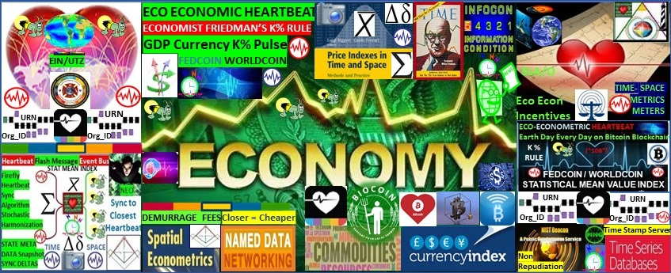



REFERENCES / LINKS / DOCUMENTS

GITHUB Documents: LINK <https://github.com/Beacon-Heart>

REDDIT: <https://www.reddit.com/user/EcoEconomicEpochs>

DISCORD: beaconheart#5893

MEWE: <https://mewe.com/i/stevenmcgee2>

MEDIUM ARTICLE: "The blockchain needs a killer use case" (climate change / population increase) LINK: <https://medium.com/coinmonks/blockchain-needs-a-killer-use-case-2f4def841883>

MEDIUM ARTICLE: Digital Nations need an Ecologically sustainable Economic Heartbeat LINK: <https://medium.com/@heart.beacon.cycle/eco-sustainable-economic-heartbeat-43e4e30246da>

MEDIUM ARTICLE: Deep Thought pondering the crypto blockchain through Alice’s Looking Glass: LINK <https://medium.com/@heart.beacon.cycle/deep-thought-pondering-the-bitcoin-blockchain-f20ad6112d7>

MEDIUM ARTICLE: "Delusional Bitcoin Vs Fool's Gold": LINK: <https://medium.com/@heart.beacon.cycle/delusional-bitcoin-vs-fools-gold-e4bea26afba8>

PIN INTEREST: <https://pinterest.com/mcgee3077/eco-economic-heartbeat/> // <https://www.pinterest.com/heartbeaconcycle/eco-economic-heartbeat/>

Angel List: <https://angel.co/heart_beacon>

MeWE: <http://mewe.com/i/stevenmcgee2>

Maven: <http://app.maven.co/profile/SHfEKnA9>

WordPress: [http://ecoheartbeat.wordpress.com](http://ecoheartbeat.wordpress.com/)

Patreon: <https://www.patreon.com/Heart_Beacon>

FACEBOOK: <https://www.facebook.com/beaconheart> // <https://www.facebook.com/HeartBeacon/>

MINDS: <https://www.minds.com/beaconheart/>

TWITTER: @Heart_Beacon <https://twitter.com/Heart_Beacon>

Subscribe Star: <https://www.subscribestar.com/eco_econ_epochs>

PAYPAL: PayPal.Me/EcoEconHeartbeat

LINKEDIN: <https://www.linkedin.com/in/ecoeconepochs/>

BEHANCE: Project site: <http://be.net/heartbeaco2eb7>

Gitter chat room for EcoEconHeartbeat/Lobby: <https://gitter.im/EcoEconHeartbeat/Lobby> via @gitchat

Proton Email (secure) [ecoeconomicepochs@protonmail.com](mailto:ecoeconomicepochs@protonmail.com)

EIN Earth Intelligence Network: see Robert David Steele’s #UNRIG proposal @ [http://robertdavidsteele.com](http://robertdavidsteele.com/)

IPFS Interplanetary File System snapshot: <https://peerweb.site/#ipfs:QmPxJNfM15WBkwEABN96yrfUmwZCajjeYtuDTGjz8C9rCw> 10/17/2020

FLOTE: <https://flote.app/Heart_Beacon>

ME WE: <https://mewe.com/i/stevenmcgee2>

Parler: https://parler.com/user/Ecoeconomicepochs

We can synchronize ourselves, our cities, towns, cyber-communities in time — space for a common purpose: shared, common, ecologically sound, equitable… econometrics. (Attributed to the Law of Time Founder RIP Dr. Jose Arguellos) see Law of Time dot org

#economic collapse #economic reset #econometrics #programmable economy #programmable money #blockchain #cryptocurrencies #sustainable development #internet #money #blockchain #cryptocurrencies #economics #sustainable #ecology #sustainability #climate change #econometrics #time-space meter, #metrics, #geospatial temporal #intensity #random number beacon #random number blockchain



Figure 6: Heart of the cryptocurrency / blockchain world: consensus algorithms

**Given myriad cryptocurrency / blockchain memes, metaphors i.e., "hashgraph" "Ether gas" "Polka "dots" blockchain theme variation projects are creating new data elements and syntax lexicons.**

**DoD / NATO's structured data exchange (mapped to symbol sets for A.I / man - machine interface) took decades to achieve** [**#consensus**](https://www.facebook.com/hashtag/consensus?__eep__=6&__cft__%5b0%5d=AZWc2TSo9bDClJhbgTQmlw_B7oVB-0IRtOpCmbv1Bgg429rTgBXCrPH9yxzIUWR-NujRSz0Kd8ZfdQnkyJbe6eD0MSZNSbgTBD6rpwgFBjmtJ0YFu33OkuP0fP9Q_T1exhw&__tn__=*NK-R) **across it’s system of systems engineering family of interoperable systems FIOP.**

**SIMPLE solution: The Standard Interface for Multiple Platform Link Evaluation (SIMPLE)** is **a**[**military**](https://en.wikipedia.org/wiki/Military)[**communications protocol**](https://en.wikipedia.org/wiki/Communications_protocol)**defined in**[**NATO**](https://en.wikipedia.org/wiki/NATO)**'s**[**Standardization Agreement**](https://en.wikipedia.org/wiki/Standardization_Agreement)**STANAG. The SIMPLE standard specifies the distributed transfer of a simulated scenario/synthetic environment using the**[**IEEE**](https://en.wikipedia.org/wiki/IEEE)[**Distributed Interactive Simulation**](https://en.wikipedia.org/wiki/Distributed_Interactive_Simulation)**(DIS) protocols. DIS is a government/industry initiative to define an infrastructure for linking simulations of various types at multiple locations to create realistic, complex,**[**virtual**](https://en.wikipedia.org/wiki/Virtual_reality)**worlds for the simulation of highly**[**interactive**](https://en.wikipedia.org/wiki/Interactivity)**activities. The SIMPLE is not limited to use for simulation and integration, and is finding applications beyond its original purpose:** [LINK](http://en.wikipedia.org/wiki/SIMPLE_(military_communications_protocol)) [**http://en.wikipedia.org/wiki/SIMPLE_(military_communications_protocol)**](http://en.wikipedia.org/wiki/SIMPLE_(military_communications_protocol))

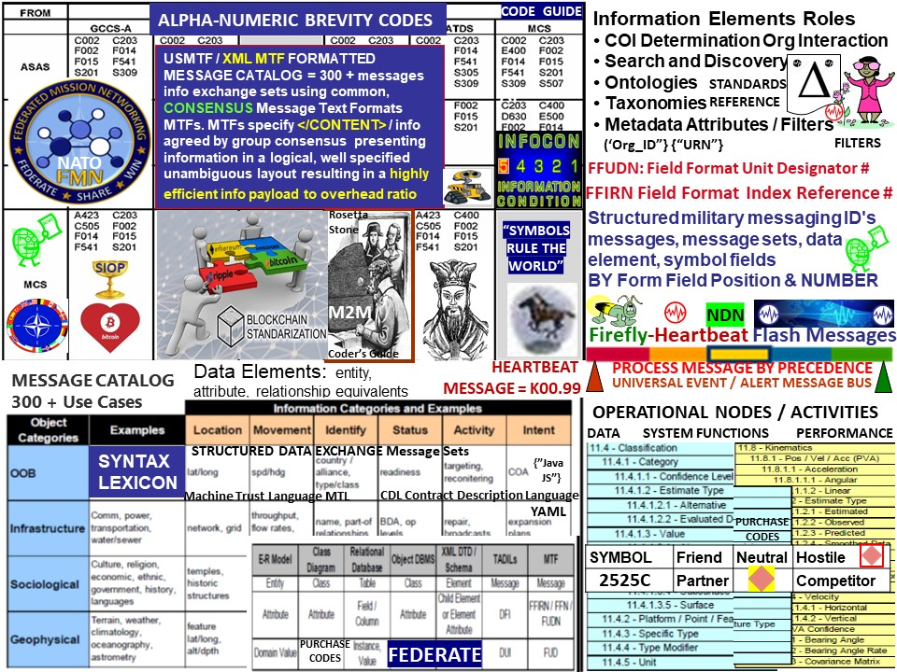

Fig 7: Syntax Lexicon library 300 + message sets / data elements mapped to symbols

NATO has invested 30 years of mapping OPSCODE brevity codes to symbology / symbols / symbol sets contained in 300 plus message set / use cases as part of Battlefield digitization, Net Centric Warfare NET Enabled Operations NEO NETOPS. Blockchain, crypto currency developers are recreating, reinventing this decades old, tedious, time intensive, labor intensive, expensive structured data exchange… wheel.

PROJECT BEACON: Reuse NATO's system of systems syntax lexicon OPSCODE brevity code structured data exchange, heartbeat micro to macro cycle Universal Time Zone UTZ sync to support an EIN Earth Intelligence Network neural net emulation. We have a clear and present opportunity and responsibility to improve temporal, geo-spatial, syntactic - semantic consistency, interoperability among myriad programmable money memes among a federated, distributed system of systems.

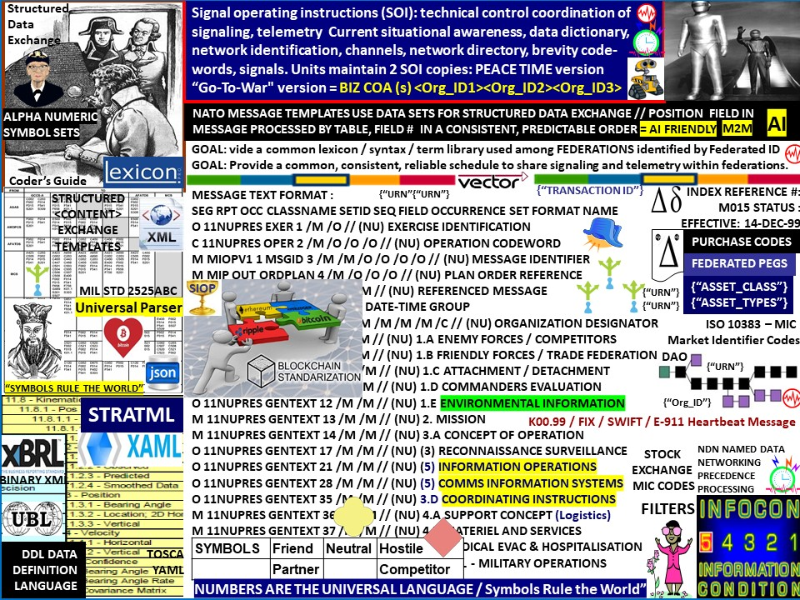

Fig 8: Syntax Lexicon library 300 + message sets / data elements mapped to symbols

The Heart Beacon Cycle Time - Space meter is a swords to plowshares DAO Distributed Autonomous Organization project using NATO’s Situational Awareness system of systems engineering framework, processes, procedures and internet building blocks to establish an Ecologically sustainable Economic Heartbeat, neural network emulation for the EIN Earth Intelligence Network and heartbeat sync pulse for a Universal Time Zone UTZ supporting a one world currency. It’s syntax lexicon library of OPSCODE brevity codes used in programmable money, the programmable economy is descriptive of internet, internet of money down to the quantum computing, quantum blockchain level. Reuse 300+ NATO cases supported by hundreds of message sets further described in spread sheet row - column format populated by thousands of brevity OPSCODES mapped to symbols essential to artificial intelligence man - machine interface. NATO bases are small cities that transact virtually every good, item, commodity with it's host nation. Why reinvent the syntax lexicon Rosetta Stone wheel



Figure 9: Proof of Stake / Eco Economic Epoch Heartbeat Cycles Time – Space Meter

Proof of stake is a type of consensus algorithm by which a cryptocurrency blockchain network aims to achieve distributed consensus. In PoS-based cryptocurrencies the creator of the next block is chosen via various combinations of random selection and wealth or age.

Proof of Stake (PoS) concept states that a person can mine or validate block transactions according to how many coins he or she holds. This means that the more [Bitcoin](https://www.investopedia.com/terms/b/bitcoin.asp) or [altcoin](https://www.investopedia.com/terms/a/altcoin.asp) owned by a miner, the more mining power he or she has.

Bitcoin miners mine or validate block transactions based on the amount of coins a miner holds. When a transaction is initiated, the transaction data is fit into a block with a maximum capacity of 1 megabyte, and then duplicated across multiple computers or nodes on the network. The nodes are the administrative body of the [blockchain](https://www.investopedia.com/terms/b/blockchain.asp) and verify the legitimacy of the transactions in each block.

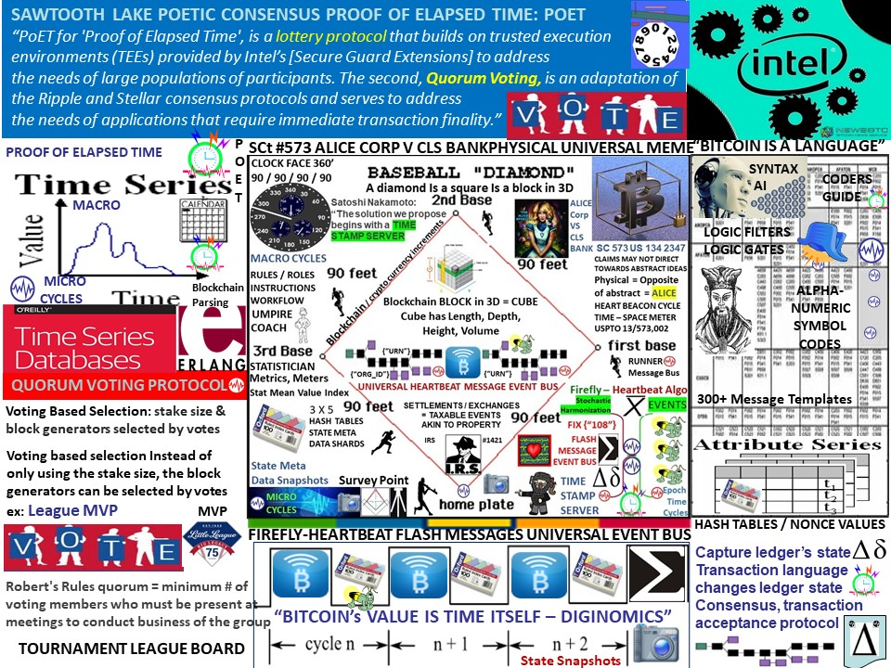

Figure 10: Proof of Elapsed Time POET / Epoch Heartbeat Cycles Time – Space Meter

Proof of elapsed time (POET) is a [blockchain](https://www.investopedia.com/terms/b/blockchain.asp) network consensus mechanism algorithm that prevents high resource utilization and high energy consumption and keeps the process more efficient by following a fair lottery system. Based on the principle of a fair lottery system where every single node is equally likely to be a winner, the POET mechanism is based on spreading the chances of winning fairly across the largest possible number of network participants.

POET algorithm working mechanism: Each node in the network is required to wait for a randomly chosen time period. The first one to complete the designated waiting time wins the new block. Each node in the blockchain network generates a random wait time and goes to sleep for that specified duration. The one to wake up first – that is, the one with the shortest wait time – wakes up and commits a new block to the blockchain, broadcasting the necessary information to the whole peer network The process repeats for next block discovery.



Figure 11: Proof of Work / Eco Economic Epoch Heart Beacon Cycle

A **proof-of-work** (PoW) system (or protocol, or function) is a consensus mechanism.It deters denial-**of**-service attacks and other service abuses such as spam on a network by requiring some **work** from the service requester, usually meaning processing time by a computer. The way that users detect tampering in practice is through [hashes](https://www.investopedia.com/terms/h/hash.asp), long strings of numbers that serve as proof of work. Put a given set of data through a hash function (bitcoin uses SHA-256), and it will only ever generate one hash. Due to the "avalanche effect," however, even a tiny change to any portion of the original data will result in a totally unrecognizable hash. Whatever the size of the original data set, the hash generated by a given function will be the same length. The hash is a one-way function: it cannot be used to obtain the original data, only to check that the data that generated the hash matches the original data.



Figure 12: Project Lightning / Segregated witness / Heart Beacon Cycle

**Lightning** is a decentralized **network** using smart contract functionality in the **blockchain** to enable instant payments across a **network** of participants. The **Lightning** **Network** is dependent upon the underlying technology of the **blockchain**. Lightning Bitcoin/**blockchain** transactions uses a native smart-contract scripting language Lightning is a "Layer 2" payment protocol that operates on top of a **blockchain**-based cryptocurrency

SegWit is the process by which the block size limit on a [blockchain](https://www.investopedia.com/terms/b/blockchain.asp) is increased by removing signature data from [Bitcoin transactions](https://www.investopedia.com/ask/answers/063015/what-does-block-chain-record-bitcoin-exchange-transaction.asp). When certain parts of a transaction are removed, this frees up space or capacity to add more transactions to the chain.

Segregate means to separate, and Witnesses are the transaction signatures. Hence, Segregated Witness, in short, means to separate transaction signatures.



Figure 13: Quantum Computing / Heart Beacon Cycle Time – Space Meter

Quantum computing is the use of quantum-mechanical phenomena such as superposition and entanglement to perform computation. Computers that perform quantum computations are known as quantum computers. Quantum computers are believed to be able to solve certain computational problems, such as integer factorization, substantially faster than classical computers.

In a **quantum** Turing machine, the difference between it and the original tape Turing machine is that the tape exists in a quantum state, as does the read-write head. This means that the symbols on the tape can be either 0 or 1 or a **superposition** of 0 and 1; in other words the symbols are both 0 and 1 (and all points in between) at the same time. While a normal Turing machine can only perform one calculation at a time, a quantum Turing machine can perform many calculations at once.

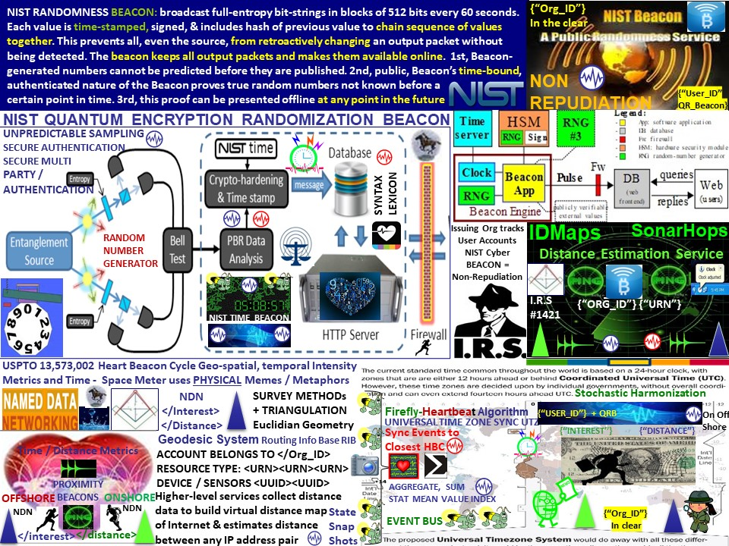

Fig 14: NIST Quantum Randomness Beacon / Heart Beacon Cycle Time – Space Meter

**NIST's** **quantum**-based **random** **number** generator, on the other hand, creates **random** **numbers** by shining an intense laser into a crystal that converts laser light into pairs of photons that are entangled, a **quantum** phenomenon that links their properties. These photons are then measured to produce a string of truly **random** **numbers**. Source: [PDF**The**NIST**Randomness**Beacon**2**](https://csrc.nist.gov/CSRC/media/Presentations/The-NIST-Randomness-Beacon-2-0/images-media/SciDay18-poster-beacon-v20181022.pdf)

This prototype implementation generates full-entropy bit-strings and posts them in blocks of 512 bits every 60 seconds. Each such value is sequence-numbered, time-stamped and signed, and includes the hash of the previous value to chain the sequence of values together and prevent even the source to retroactively change an output package without being detected. NIST Randomness Beacon [LINK](https://beacon.nist.gov/home)

Many in the programmable money space think quantum computing will obsolete the crypto currency #blockchain. In my opinion, the opposite is true - the programmable economy will be anchored by quantum computing - specifically NIST's Quantum Random Number Beacon / Github: <http://github.com/Beacon-Heart>

Fig 15: NIST Quantum Random Number Beacon / Time Beacon / USPTO 13/573,002

Quantum Computing: **Quantum** **computing** is the use of **quantum**-mechanical phenomena such as superposition and entanglement to perform computation. **Quantum** computers are believed to be able to solve certain computational problems, such as integer factorization. in a **quantum** Turing machine, the difference is that the tape exists in a quantum state, as does the read-write head. This means that the symbols on the tape can be either 0 or 1 or a **superposition** of 0 and 1; in other words the symbols are both 0 and 1 (and all points in between) at the same time. While a normal Turing machine can only perform one calculation at a time, a quantum Turing machine can perform many calculations at once.

Quantum Random Number Generator: The NIST method generates digital bits (1s and 0s) with photons, or particles of light, using data generated in an improved version of a landmark [2015 NIST physics experiment](https://phys.org/news/2015-11-nist-team-spooky-action-distance.html). That experiment showed conclusively that what Einstein derided as "[spooky action](https://phys.org/tags/spooky+action/) at a distance" is real. Researchers process the spooky output to certify and quantify the [randomness](https://phys.org/tags/randomness/) available in the data and generate a string of more random bits. [LINK](https://phys.org/news/2018-04-quantum-method-random.html)

Time filtered and spatially metered reports are comprised of state meta-data snapshot / heartbeat message / sync delta messages where state meta data is harvested during micro-cycles then posted / displayed during longer macro-cycles

See hop count treatise referential to internet / TCP/IP treatises Figure 11

IEEE 802.11AG is used for hop by hop detection and control for epoch assignment and hop

counts management and for hop by hop detection function to determine hop by hop count

corresponding to machine readable and executable null / 0 and steps from null representing hop

counts e.g., +1, +2, +3, +4 and / or -1, -2, -3, -4 Paul Revere linear, sequential metaphor

indicating distance traveled in context with router / server / switch / node traversal

IEEE 802.11 HbH hop by hop control supporting Paul Revere, rain drop in pond metaphor

metrics of increases / decreases in thresholds and by intensity, duration and hop count sums



Figure 16: Synchronization across Time - Space

We can synchronize ourselves, our cities, towns, cyber-communities in time — space for a common purpose: shared, common, ecologically sound, equitable… econometrics.



Figure 17: Financial Nostradamus / FutureMan fusion

Veritaseum is a blockchain-based fintech software company which delivers global access to peer-to-peer capital markets through its decentralized platform, digital asset research, and transfers. At heart, the project seeks to level the economic playing field by creating software which enables participation in P2P capital markets without intermediates like banks, brokers, financial advisors, and other mediators. The use case of VERI token is to redeem with Veritaseum software for advisory services, research and to gain entry into Veritaseum’s autonomous financial machines, P2P value trading system, and P2P letters of credit. The platforms utility token VERI is used to purchase access to the platform's products and services, which range from asset tokenization to financial research data and even self-custody escrow services. VeADIR stands for Veritaseum Autonomous Distributed Interactive Research. It is the core component of the platform. It gives exposure to vetted research subjects and serves opportunities to grow its asset base through positive risk-adjusted returns. For instance, if someone wants to invest in an ICO and needs comprehensive information to weigh the risks, they can submit a query via VeADIR, pay with VERI and receive the requested information from Veritaseum. Research results then are fed back into the VeADIR system, and the cycle continues. All information is transmitted in machine learning language and needs to be translated to common vernacular using smart contracts. Source: <https://cryptonews.com/coins/veritaseum/>



**FIGURE 18: One World Currency FEDCOIN / WORLDCOIN**

**A one world currency for the one world government will require financial events stochastic-ally synchronized, harmonized across the world's time zones and will need to represent a value index of the world's GDP Gross Domestic Product**

**Course of Action: Use Thomas Edison's commodity backed index recommendation 1921, Milton Friedman's K % rule, Economist Bernard Lietaer's TERRA TRC Trade Reference Currency concepts in concert with the firefly-heartbeat algorithm developed by the University of Bologna, University of Hungary = ECONOMIC HEARTBEAT FEDCOIN / WORLDCOIN**



Figure 19: Big Picture / Beacon Communities

Heart Beacon Cycle Time – Space Meter: One method fits many not one size fits all

Adaptive Procedural Template (checklist):

* Use Case: Eco Economic Epochs Time-Space Meter Ecologically sustainable Eco incentives, consensus, interoperability, stochastic UTZ Universal Time Zone harmonization & synchronization for programmable money / economy.

#economic collapse #economic reset #econometrics #programmable economy #programmable money #blockchain #cryptocurrencies #sustainable development #internet #money #blockchain #cryptocurrencies #economics #sustainable #ecology #sustainability #climate change #econometrics #time-space meter, #metrics, #geospatial temporal #intensity #random number beacon #random number blockchain

REFERENCES

GITHUB Documents: [LINK](https://github.com/Beacon-Heart/Heart_Beacon) <https://github.com/Beacon-Heart>

MEDIUM ARTICLE: "The blockchain needs a killer use case" (climate change / population increase)

MEDIUM: <LINK>: <https://medium.com/coinmonks/blockchain-needs-a-killer-use-case-2f4def841883>

MEDIUM ARTICLE: Digital Nations need an Ecologically sustainable Economic Heartbeat

[LINK](https://medium.com/@heart.beacon.cycle/eco-sustainable-economic-heartbeat-43e4e30246da): <https://medium.com/@heart.beacon.cycle/eco-sustainable-economic-heartbeat-43e4e30246da>

MEDIUM ARTICLE: Deep Thought pondering the crypto blockchain through Alice’s Looking Glass: [LINK](https://medium.com/@heart.beacon.cycle/deep-thought-pondering-the-bitcoin-blockchain-f20ad6112d7) <https://medium.com/@heart.beacon.cycle/deep-thought-pondering-the-bitcoin-blockchain-f20ad6112d7>

MEDIUM ARTICLE: "Delusional Bitcoin Vs Fool's Gold": [LINK](https://medium.com/@heart.beacon.cycle/delusional-bitcoin-vs-fools-gold-e4bea26afba8):  <https://medium.com/@heart.beacon.cycle/delusional-bitcoin-vs-fools-gold-e4bea26afba8>

Angel List: <https://angel.co/heart_beacon>

Patreon: <https://www.patreon.com/beacon_heart>

FACEBOOK: <https://www.facebook.com/beaconheart>

MINDS: <https://www.minds.com/beaconheart/>

TWITTER: @Heart_Beacon <https://twitter.com/Heart_Beacon>

PAYPAL: PayPal.Me/EcoEconHeartbeat

PIN INTEREST: <http://pinterest.com/mcgee3077/>





“Build a new model” RBF

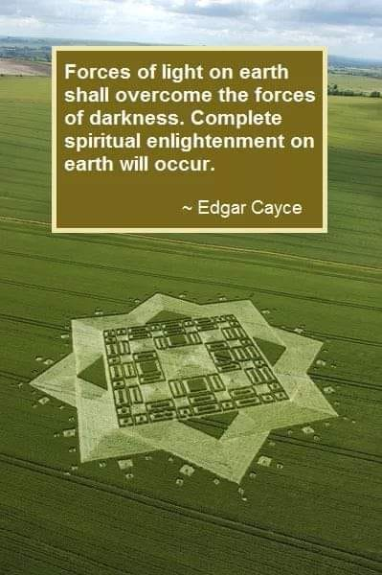



“Be the change you want to see in the world” Ghandi / How to change the world

